**Document (Technical Details for Proposed Robot)**

Wherever necessary separate sheet/page is allowed to attach; Institute may submit extra details if find necessary

1. Type of Robot: Submarine / Underwater robot
2. Robot Assembly Design (Proposed Diagram): Drawings each part of the robot is preferred as an attachment. (CAD drawings are preferred).
3. Components to be used:
4. List of Structure components:
   1. 12.8V 6000mAh LiPo battery
   2. [like beams, bushes, shafts, belts, plates, pins, pullies, wheel, connectors, batteries, motors etc.]
5. List of Motion Components:
   1. Thruster + impeller

(Custom made from ABS plastic)

* 1. BLDC motor with custom plastic housing

1. List of Electronics Components:
   1. Fly-ski CT-6B 6-channel Remote Control with FS-R6B receiver

(2.4GHz 6-channel Remote Control transmitter and receiver)

* 1. Arduino UNO and ESP32 module
  2. 5.8G UVC OTG Android Audio-Video Phone Receiver
  3. TS5828L 5.8G 600MW 40CH Transmitter with antenna
  4. 600TVL 170deg mini-FPV AV Camera
  5. Infrared LEDs
  6. [like smart pods, switches, joysticks, controllers, LED/LCD screen, power supply, programming components etc.]

1. List of other Accessories: Waterproof body with ABS plastic material
2. 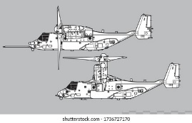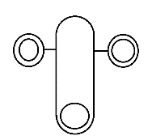The methodology of Making Robot: The first idea of the submarine robot was to have a 3-motor robot, with one motor at the back and 2 in front. The front motors were also supposed to rotate. This design was inspired by the rotating engines of the aerial vehicle V22 Osprey. The first picture is the rough design on top view of this idea. The second picture is the V22 Osprey reference.

The second idea was a 6-motor robot, with 2 upward-facing motors and 4 horizontal motors. These motors would be attached diagonally, with opposite motors being parallel. The given picture is the rough design of the top view of this idea. The arrows point in the direction the motor will face, and a motor facing upwards is shown by a hollow star shape.

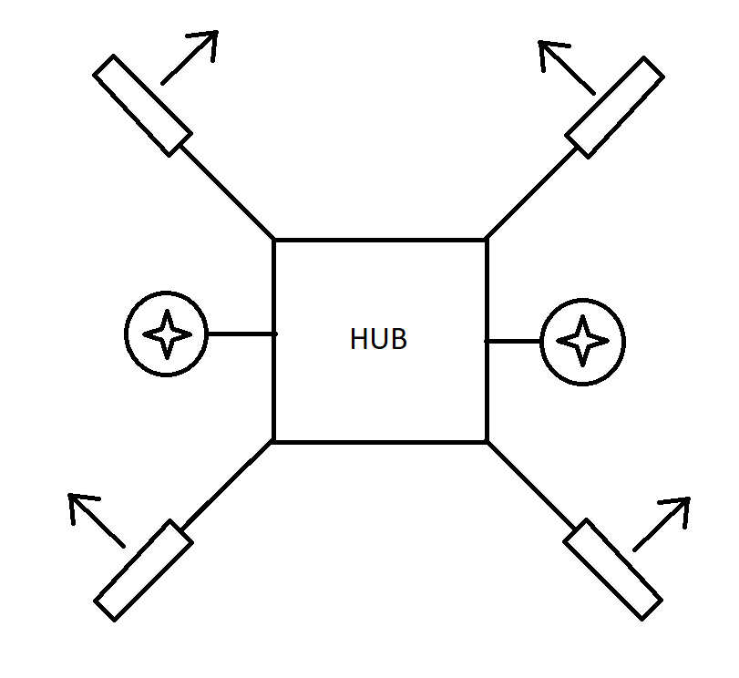

The third (current) idea is almost the same as the previous one, but the 2 motors facing up are now facing down (shown by filled star shape). Also, blocks of foam are added to the top to make the robot float. This design has a few differences from the previous one, as follows:

* It has foam blocks which help it float up. This allows the robot to float to the surface in case of a power loss
* It has down-facing motors (shown by filled star). They will push the robot down.
* It has an integrated frame, making it more stable that the previous design

The picture below shows the robot with foam blocks and down-facing motors. The frame has not been included.

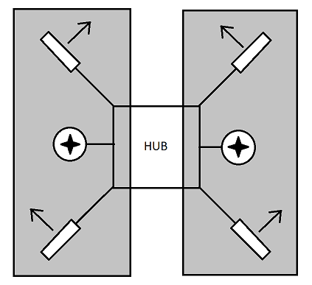

The above picture is the current design of the robot.

Below are a few specifications of the electronic components of the robot.

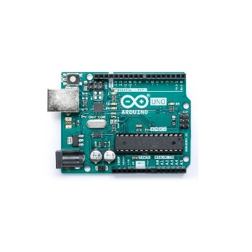Arduino UNO

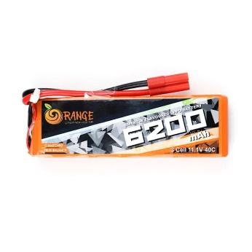Battery 12.8V 6000mAh Lithium Polymer

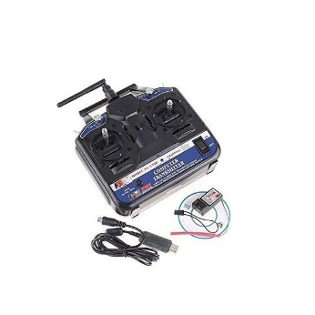Remote Fli-Sky CT-6B 6 Channel Remote and Receiver

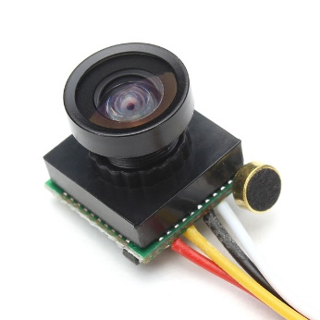Camera 600TVL 170deg mini-FPV Audio-Video

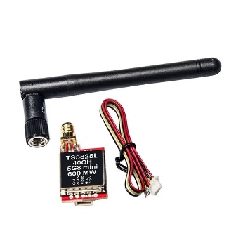 Audio-Video transmitter TS5828L 5.8G 600MW 40CH with antenna

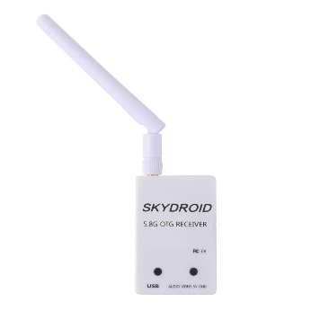 Android Audio-Video Phone Receiver 5.8G UVC OTG

1. Application of proposed Robot in a societal context: The attached robot design provides sufficient maneuverability while also having a relatively small size. This enables it to access inaccessible areas, such as deep-water dam walls, underwater cave systems, and structures such as oil rigs, pipelines, or submerged supports of bridges. Moreover, such a robot allows marine researchers and biologists to study marine ecosystems like coral reefs. Finally, it can easily be modified for use cases like defense, navigation, and search-and-rescue.
2. Size of Robot proposed for Proof of Concept (Small Version):
3. Length: 36 cm max
4. Width: 36 cm max
5. Height: 18 cm max
6. Size of Robot proposed as prototype (Actual Version):
7. Length: 45 cm
8. Width: 45 cm
9. Height: 22.5 cm
10. Timeline for Robot Making with milestones

* *[Upon clearing Ideation stage, 15 January]*
  + Assembling parts and testing stability of Proof of Concept – 21 days (3 weeks)
  + Writing program to control robot – 14 days (2 weeks)
  + Testing in real water, making required modifications – 14 days (2 weeks)
  + 1 week as buffer
* *[Submission of Proof-of-Concept Robot, 15 March]*
* *[15 days buffer]*
* *[Upon clearing Proof of Concept stage, 31 March]*
  + Acquiring parts for Full Scale model – 7 days (1 week)
  + Assembling Full Scale model using parts – 21 days (3 weeks)
  + Importing movement code from previous robot – 14 days (2 weeks)
  + Testing robot movement and making modifications – 14 days (2 weeks)
  + Writing program for Grand Objective – 14 days (2 weeks)
  + Testing Grand Objective – 7 days (1 week)
  + 1 week as buffer
* *[Submission of Full-Scale Prototype Robot, 30 June]*

1. Please attach the proposed outline (photography) for understanding of the evaluation committee.